Syllabus
Goal:
The purpose of this course is to expose students some basic techniques used in molecular gastronomy and to open their minds to the possibilities that can be realized using these and other molecular gastronomy techniques. This is communicated through a mixture of lecture regarding the techniques and the science behind them as well as hands on lab time where students will take part in the creation of three distinct dishes inspired by the techniques they are learning.
Theme:
The techniques and ideas featured in this course revolve around the theme of transformation: taking food beyond its familiar preparations while still preserving the essence of what a dish is. Students will not only learn the techniques, but will see the thought process behind creating dishes inspired by these techniques and the transformations of food that molecular gastronomy allows.
Organization:
Students will first be introduced to molecular gastronomy through a short lecture and presentation by the instructors that includes examples of famous molecular gastronomy preparations. The class will then begin focusing on the four techniques to be covered. The dishes they will make are designed in such a way that only one or two techniques are required to create them. This allows students to apply the techniques they learn immediately as the lecture moves on and transitions to a lab format. After making and sampling a dish with the technique they learned, the students will receive further lecture on the remaining techniques and be presented with more lab time to apply each of them.
Topics:
1. Origins of Molecular Gastronomy
2. Power of Transformation
3. Basic Spherification
4. Reverse Spherification
5. Powderizing Fats using Tapioca Maltodextrin
6. Agar Agar Gels

Dishes:
Edamame Chip n’ Dip – Small 'caviar' spheres made of filtered edamame puree as well as caviars of soy sauce set on a chip made of fried edamame dough strips.
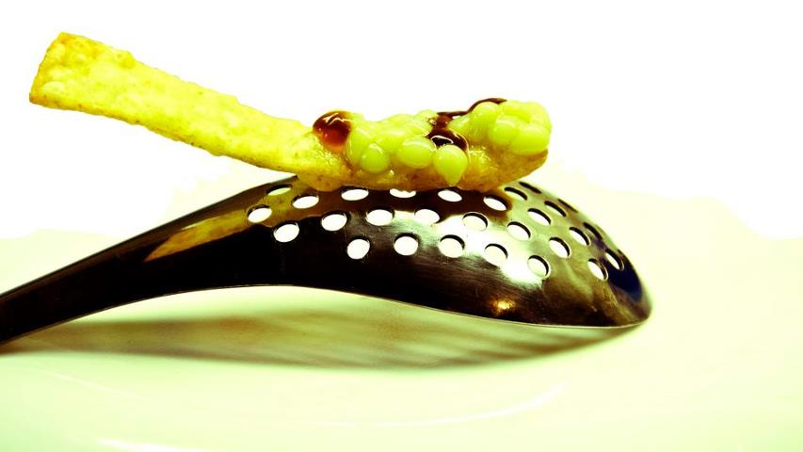
Thousand Year Sphere – A reverse sphere of thousand year egg congee topped with drops of pepper oil, sesame oil, chinese vinegar, pickled daikon, and green onion.
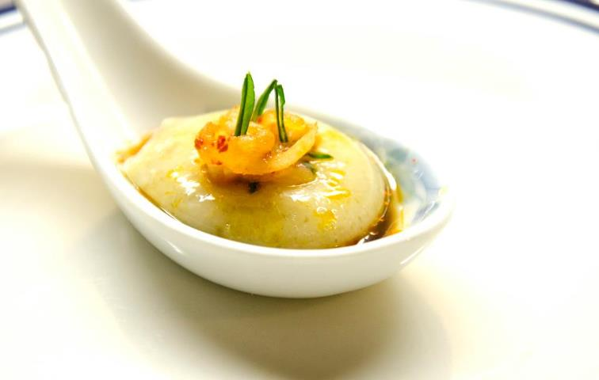
Chocolate Banana Pasta and “Meatballs” – Agar agar noodles topped with nutella powder served with sticky rice balls

